Team 06 Project Proposal: New App for Newegg Procurement

**TA Name: Rushitha Akula**

**Problem Statement:**

Newegg is a leading electronics retailer focusing on computer hardware. While the current Newegg app provides essential functionality, its UI and backend model are outdated. Consequently, the user experience is lacking in quality as shoppers experience slow loading times, inefficient product searches, and unresponsive stock updates. Eventually, shoppers miss out on good deals as scalpers thrive to disrupt the market. An update on Newegg procurement is very urgent.

**Solution:**

To address the challenges of Newegg’s outdated UI and backend inefficiencies, we propose a comprehensive update to its procurement system, enhancing both the front-end user experience and the backend infrastructure.

**Users:**

Network: Newegg.com

Enterprises: Retail, Logistics, Supplier, FintechPay

Organizations – Shopify, UPS International, Customs Office, Ali Express, Ali Pay, 3rd Party Customer Experience Center

Role – Merchant, Logistics Coordinator, Payment Processor, Customs Agent, Customer Service Rep, System Admin, Procurement Specialist, Warehouse Manager

**Actions:**

* Restock(Shopify, UPS International)
* Anti-fraud(Shopify, Ali Pay)
* Generate orders and initiate shipping (Retail, Logistics, FintechPay)
* Problem feedback(Customer Service Rep,Procurement Specialist, Warehouse Manager)

**Use Case:**

Merchant

* Product listing and management
* Upload and Edit product information on the E-Commerce Platform (product name, detailed description, specifications, price, inventory quantity, etc;Edit or undercarriage)
* Sales data analysis(sales report,Include sales volume, sales volume, sales geographic distribution, etc., in order to understand sales trends)
* Check the inventory

Logistics Coordinator

* Manage shipping (Select carriers - UPS, route, and shipping methods)
* Tracking packages (Status updating: location, date)
* Manage cancels
* Resolve delays, damages, lost packages, etc.
* Coordinate with customs agents for cross-border shipments (provide necessary documentation)
* Optimize shipping costs and delivery times (Implement map API)
* Manage own profile

Payment Processor

* Verify payment
* Check fraudulent transactions
* Implement anti-scalper technique

Customs Agent

* Prepare documents (Add commercial invoices, packing lists)
* Classify products according to codes (Optional: implement DB)
* Calculate duties and taxes
* Respond to customs inquiries and requests for additional information
* Coordinate with logistics coordinators on customs clearance status
* Process returns and refund (Duty refund)
* Manage own profile

Customer Service Rep

* Recieve the customer complaint.
* Send the message to Warehouse Manager(Storage issues）,Logistics Coordinator(shipping problem),Procurement Specialist(Quality issues）

System Admin

* Oversee all user info
* Maintenance and troubleshoot
* Suspend suspicious activities

Procurement Specialist

* Receive the request by ware manager
* Select suppliers and complete the order process
* Track purchase orders (check whether it has arrived at the warehouse

Warehouse Manager

* Check stock level
* Manage incoming products
* Package products for logistics·

**High-level component diagram**

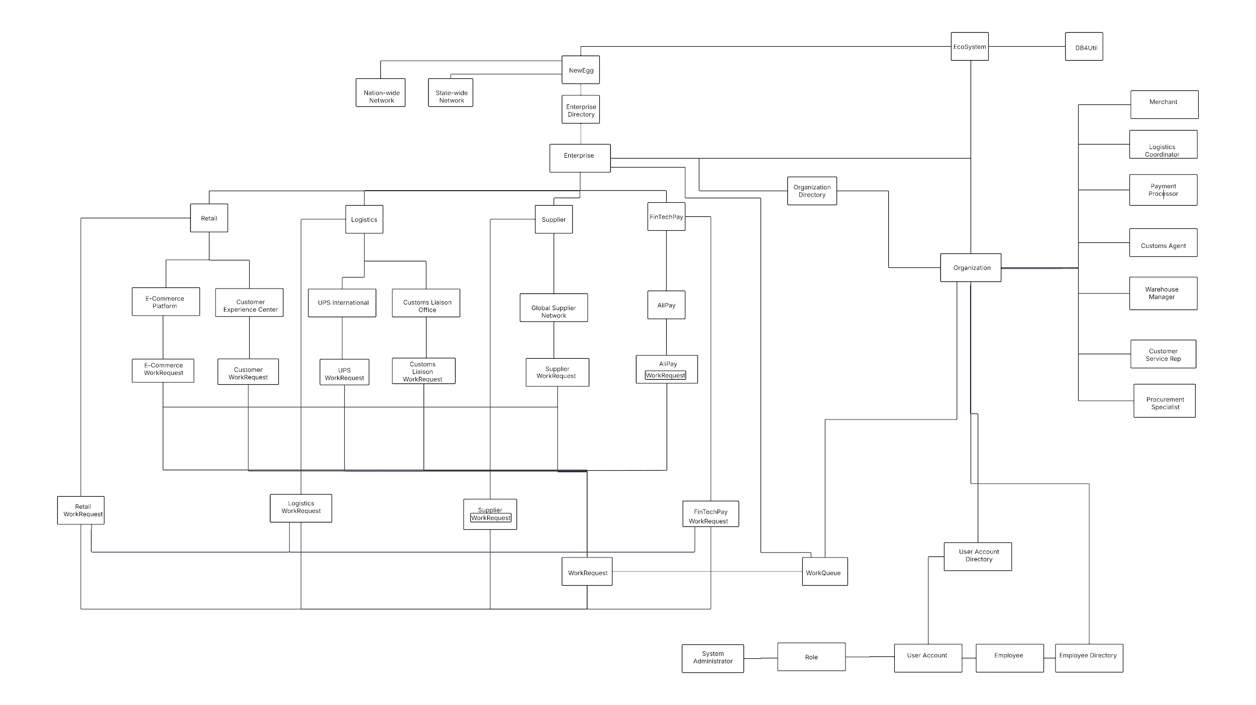

URL:  
https://lucid.app/lucidchart/6946c0b2-3322-4fb7-afe1-4da76c61311f/edit?invitationId=inv_96f2c9d4-9805-429e-ba34-7084ffec13a6&page=Is76bH~WfK-I#

Interaction:

1. Warehouse manager package orders for logistics ←→ Logistics Coordinator collect package from warehouse
2. Warehouse manager receive returned order ←→ Payment processor issue refund
3. Payment processor receive payment ←→ warehouse manager prepare item for shipping
4. Payment processor detect fraudulent transaction ←→ system admin suspend order